Reviewer reports:  
  
**Reviewer #1:** *Colon cancer is the 3rd lethal malignancy in the world whose early detection would greatly benefit from the blood based measurements, and cell free DNA methylation abnormality has been proved to be one of the most promising biomarkers for early cancer diagnosis in multiple cancer types. In this study, Fan and co-workers identified some differentially methylated CpG sites by comparing DNA methylation profiles of pre-cancer adenoma specimens to normal colon tissue samples, and by integrating other public datasets, Fan and coauthors revealed DNA methylation at promoter of ADHFE1 is the most promising diagnostic biomarker. Overall, the manuscript is well written, and analysis is well done, and the whole study is likely to generate considerable interest in the field. However, some key questions need to be addressed before I make my further decision.*  
*“1. The authors profiled DNA methylation for 18 LGA, 22 HGA and 20 normal tissues, and found significant DNA methylation differences across them. Authors should provide a detailed QC metrics and DNA methylation correlation coefficient across samples within each tissue type to demonstrate the technique reproducibility and methylation homogeneity in each tissue type.”*

**Response:** Thank you for the suggestion. We described QC details in the part of Methods and a few additional statements was included in revised version. Basically, we tried first to ensure similar numbers of Normal, LGA and HGA samples on each array. Then, we used the Methylation module in GenomeStudio software (version 1.8, Illumina) for data processing including normalization, background adjustment, and methylation calculation. To ensure above QC process, an evaluation report (Figure S8 and Figure S9) was included in this revised manuscript.

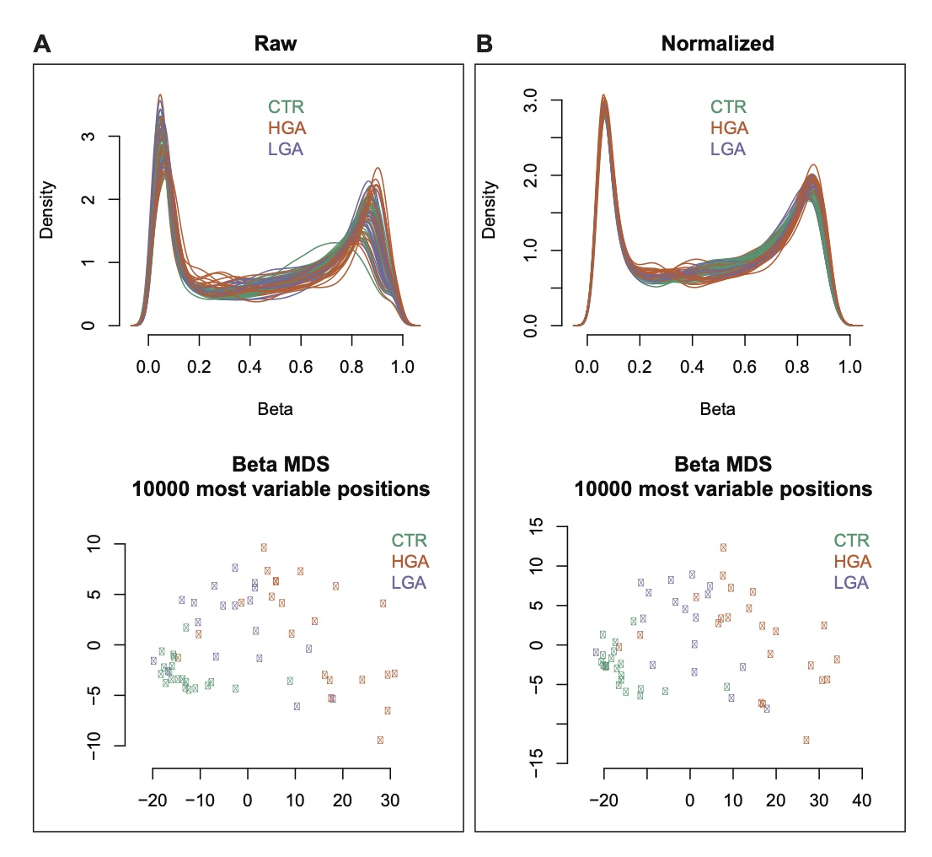

**Figure S8.** Density of all beta values (top panel) and multi-dimensional scaling (MDS) (bottom panel) according to 10000 most variable positions for samples in high grade adenoma (HGA), low grade adenoma (LGA) and normal tissue (CTR) before (A) and after (B) normalization. The density plots demonstrate relatively consistent distribution of beta values across all sample even before normalization. According to the 10000 most variable positions, the MDS plots show the samples clustering according to their pathological groups. Particularly, normal tissues (green dots) have high homogeneity, forming a dense cluster in the bottom left corner of the plot; and heterogeneity of samples increase from normal tissues, low-grade lesions (orange dots) to high-grade ones (purple dots), as sample dots having increased spacing from bottom left to top right.

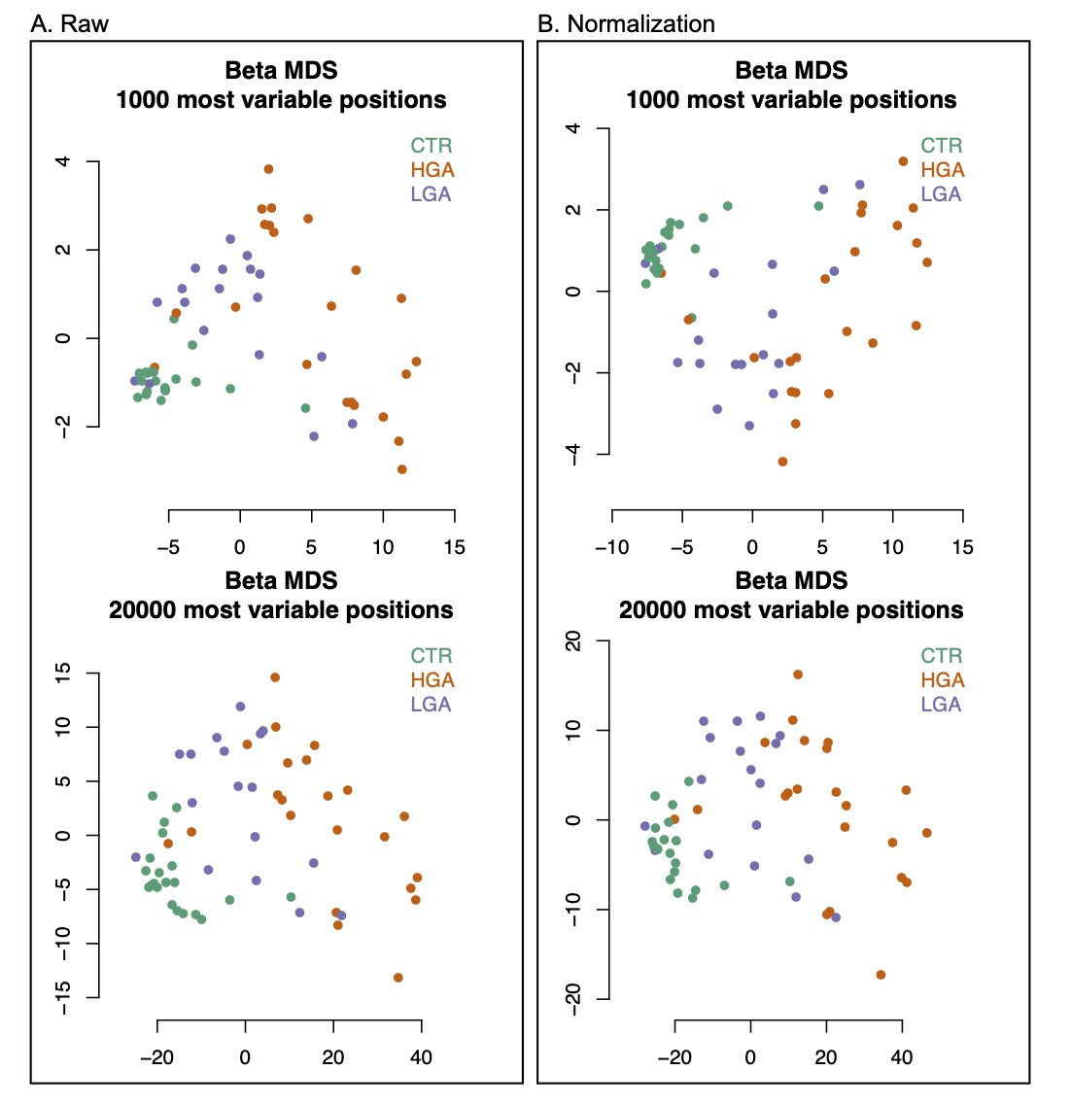

**Figure S9.** Multi-dimensional scaling (MDS) according to 1000 (Top panel) and 20000 (Bottem panel) most variable positions for samples in high grade adenoma (HGA), low grade adenoma (LGA) and normal tissue (CTR) before (**A**) and after (**B**) normalization.

*“2. Little information is provided for the therapy regimen for the patients whom the authors obtained specimens from. Different drugs may have different levels of effects in shaping the DNA methylation, or are they all treatment naïve?”*

**Response:** In our revised version, a list showing patient information was included. In brief, all the patients were drug treatment naive (no any treatment before their surgeries), except for one with chemo- and radio-therapies 8 months prior to his surgery.

*“3. This is a key point, since the authors identified some differentially methylation CpG sites and claimed some of the sites might be useful for early detection. The author should check the methylation status of these CpG sites in the blood samples from normal individuals from public databases. Without this data, the clinical utility and the sensitivity of their findings is questionable.”*

**Response:** Thank you for the important suggestion. Accordingly, in our revised version, as a new Table (Table S1), we included the details of the methylation values in our identified 209 hyper-methylated DMSs in LGA. As suggested we also checked the DNA methylation level of these 209 sites in 656 cases of human whole blood from GEO (accession number GSE40279) and plotted a heatmap as Figure S7 as shown in below. Indeed 207 out of 209 sites showed their low methylation level as < 0.3 in average, which was significantly different from those in tumor and adenoma tissues. We also examined the DNA methylation level of ADHFE1 promoter in these 656 cases of whole blood and low level of methylation at all the cases was observed.

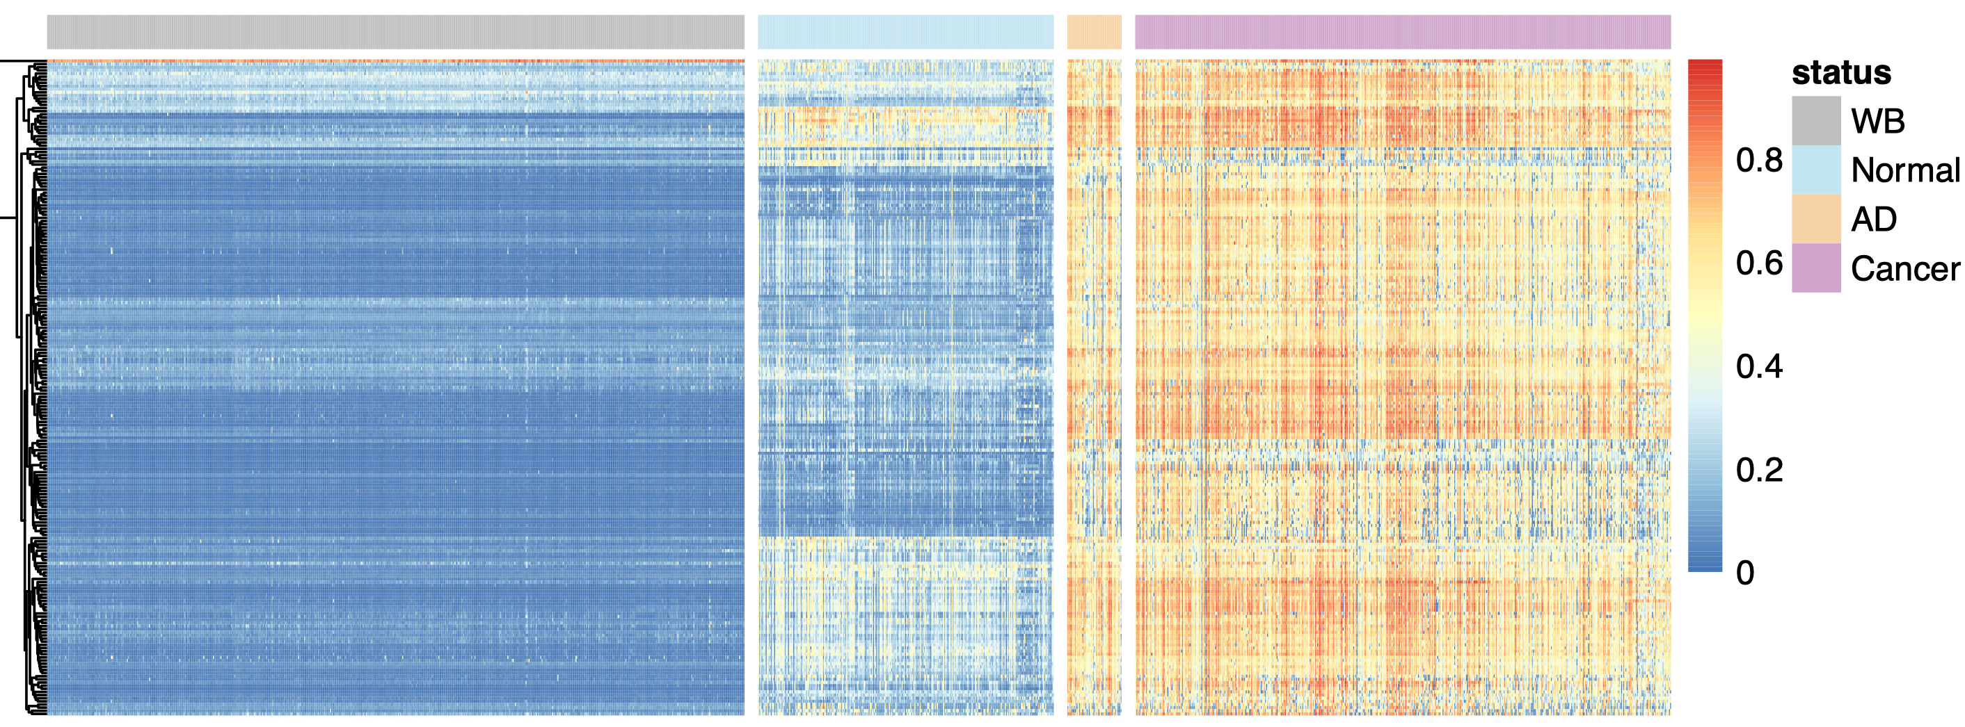 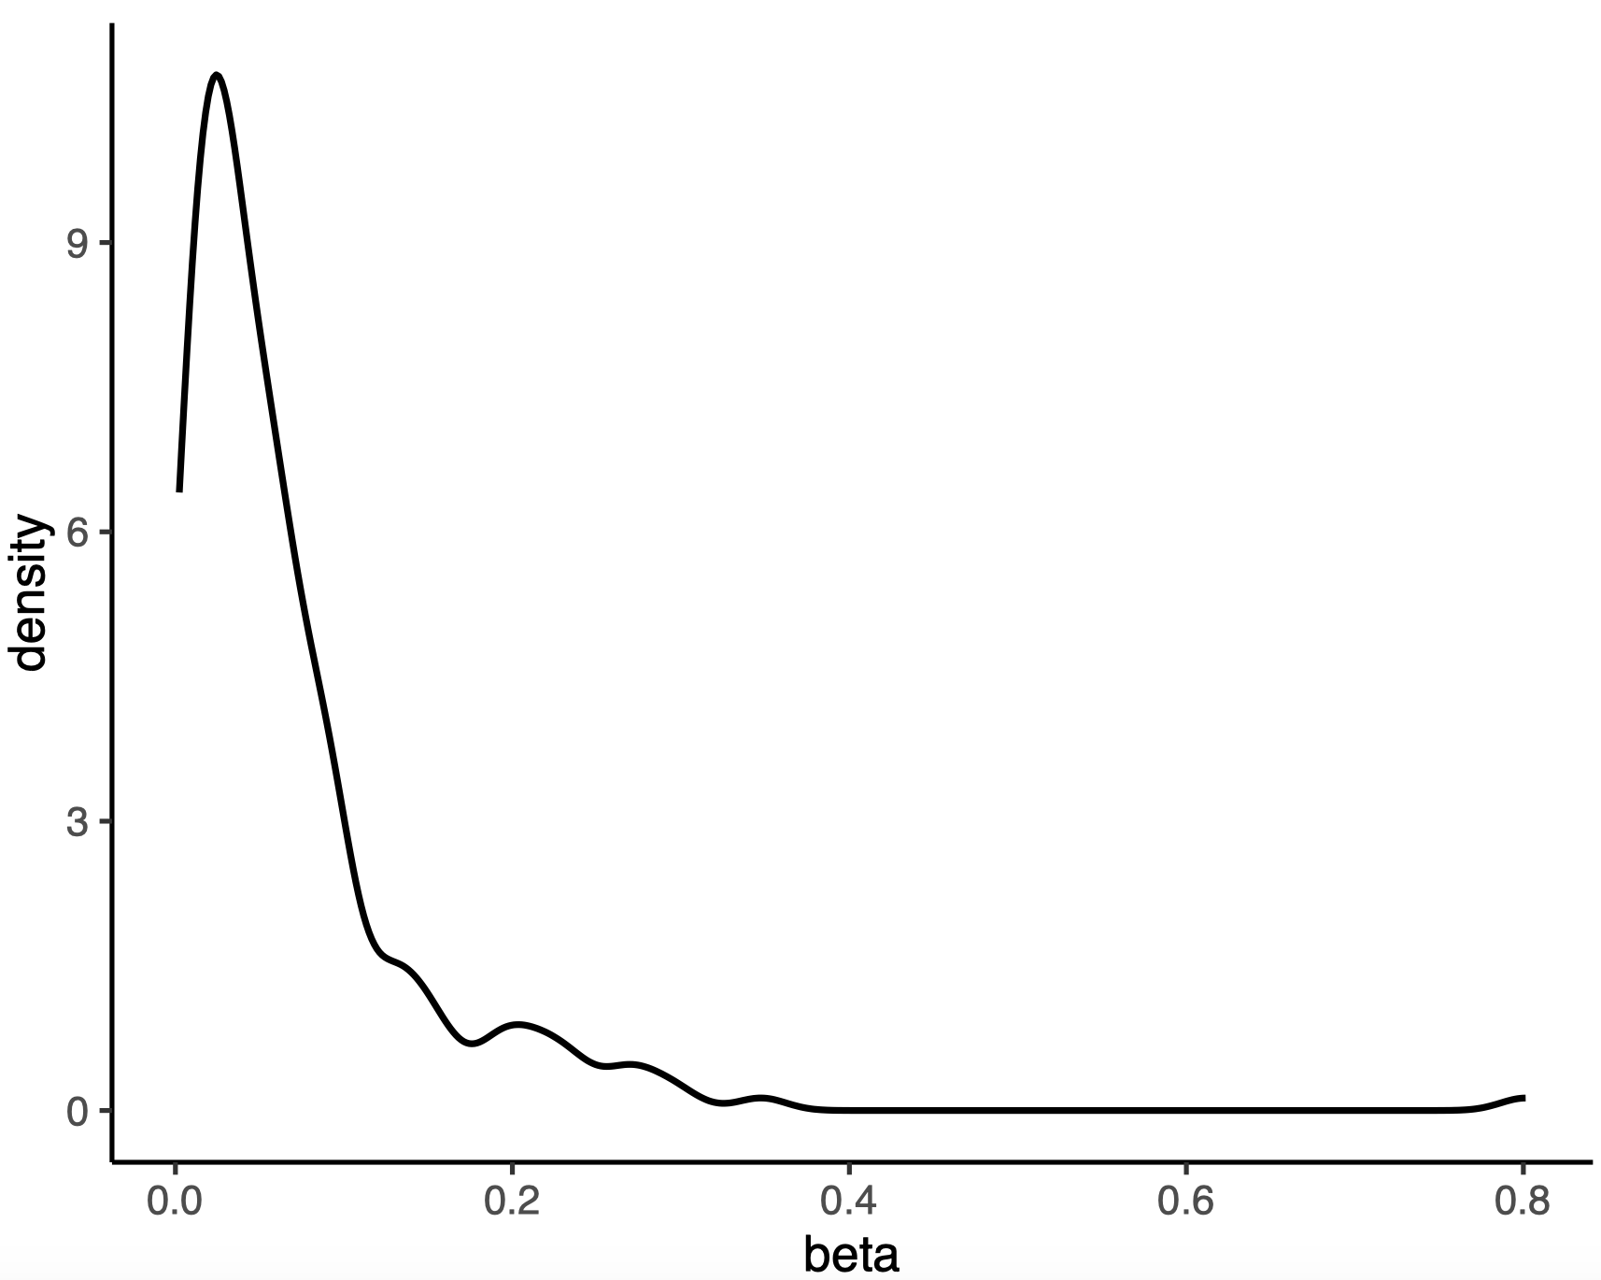

**Figure S7.** Methylation levels in our normal samples (Normal) and public datasets (WB, AD, and Cancer) for 209 hyper-methylated DMSs identified in LGA. (Left) Public datasets include 656 whole blood (WB) samples and 51 adenoma (AD) and 504 cancer samples. (Right) Density plot of DNA methylation levels (beta values) of 209 sites in all samples.

*“4. The pathway analysis highlighted gut-brain-axis aroused a very interesting concept that the cross-talk between neuron system and GI system may be interrupted during carcinogenesis. Authors should provide other data (ie. immune staining of some key protein molecules in different tissue types) to strengthen their claims.”*

**Response:** Thank you for the suggestion. Indeed, the interaction of tumor and the nervous system was also found in other cancers, such as in gastric cancer and liver cancer (PMID: 31647986, 29660379). We included these two papers in our reference in revised version. Since we have no sample left after methylation analysis, currently we are unable to do staining in presented samples. This will be further studied in our follow-up research accordingly.

*“5. The authors compared ADHFE1 with SEPT9, and found a better prediction power of ADHFE1 over SEPT9,* *authors should check if ADHFE1 is some way orthogonal to any of these FDA-approved biomarkers, including SEPT9 and carcino-embryonic antigen (CEA).”*

**Response:** Thus far only SEPT9 was approved by FDA as the cfDNA diagnostic marker of colorectal cancer at DNA methylation level. We then analyzed the correlation between ADHFE1 and SEPT9 as suggested. As shown in newly included Figure S5, the correlation of DNA methylation of these two genes was 0.77. As for the comparison with CEA, since CEA is not a routine test item for outpatient adenoma clinic, we were unable to obtain data from collaborating hospital or in public database.

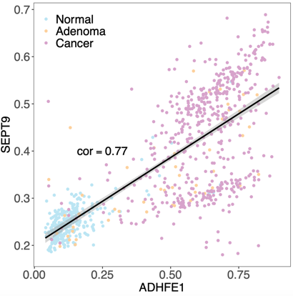

**Figure S5.** The correlation of methylation levels (beta value) between *ADHFE1* and *SEPT9*.

*“6. One article published recently on* *Science Translation medicine describing the cfDNA methylation for early detection of colon cancer, authors should cite and discuss.”*

**Response:** Indeed, we should compare our result with circulating samples. In new version we discussed the results described in reviewer suggested article, especially the methylation level change of cg10673833 found in that study. The methylation level of this site showed only a slight upward trend in tissues from normal to adenoma and cancer, in our samples as well as in public data. Therefore, most likely this cfDNA marker demonstrated good correlation for cancer development in blood samples but not the change from normal tissue to adenoma and cancer.

**Reviewer #2:** *Review of the manuscript  " Genome-wide DNA methylation profiles of Low- and High-grade adenoma reveals potential biomarker for early diagnosis of colorectal carcinoma"*

*“1. The reviewer thanks for the opportunity of this interesting manuscript, whose separate parts are of excellent, but the paper in all requires* *thorough emphasis and work together of the independent findings found in the present form of the manuscript. The title itself shows  some* *contradiction that can be refound in the whole manuscript. The authors aimed  identification of biomarkers of  early diagnosis of colorectal carcinoma in tissue ?”*

**Response:** We took the reviewer’s point, in this version, we changed title as “Genome-Wide DNA Methylation Profiles of Low- and High-Grade Adenoma Reveals A Potential Biomarker for Early Detection of Colorectal Carcinoma”.

*“2. The authors identified early adenoma markers , but they have not validated them, not tested in cell free DNA ( liquid biopsy), either . The authors expanded findings from early, LGA adenoma to HGA and in silico , to publicly available  cancers. The reviewers asks why ? Cancer epigenetic data, markers  are overwhelmingly available. Validated adenoma and cancer data are far less e.g. (* *Patai AV et al. Dig. Dis 2012,* *Patai AV et al. PLOS ONE 2015) .”*

**Response:** Indeed the reviewer pointed an important issue, i.e., the performance of our candidate marker in liquid biopsy. This is our follow-up study and we are currently in the process of finding collaborators for sample collection. Our finding started from LGA and HGA since we believe as the precancerous lesion, using adenoma tissues may lead us to discover the early marker for cancer diagnosis. Currently most methylation markers were initially identified in cancer tissues and usually with less sensitivity in detection for stage I of CRC. Therefore, our result of ADHFE1 from adenoma appears promising in early detection so we focused on the tissue samples to identify candidates first then tested their performance in the public datasets.

We apologize for lacking of inclusion of certain papers especially for a related review. We discussed related results in revised version. In brief, for the ten genes validated in one study (PLoS ONE) were all hyper-methylated in our data, which to some extent is consistent with our results.

*“3. If the aim of the work is not the tissues diagnostics but more a liquid biopsy diagnosis based early diagnosis of cancer, the identified biomarker ADHFE1 should have been tested in cell free circulating DNA samples, as well.”*

**Response:** As mentioned above, candidate marker in cfDNA is our follow-up study. Regarding the samples used in current study, we were unable to obtain cfDNA since as the outpatients no blood withdraw procedure for these individuals.

*“4. The authors compare the ADHFE1 marker to septin9, however SEPTIN 9 tissue sensitivity and specificity data ( Toth et al.Pathol. Oncol. Res 2012,* *Toth K. et al Plos One 2012, and 2014) are not referred, rightly.”*

**Response:** We thank the reviewer to point out this missing of statement and we included related references accordingly.

*“5. The authors have identified 209 hypermethylated positions in their one data, in LGA cases. These markers were found further methylated in HGA (authors' own data ) and 504 publicly available cases.   
The authors do not describe the correlation of their finding to publicly available LGA or HGA or adenoma (50 are available according to their materials and methods section) specimen. This would be specially necessary as no validation is done in this study, at all.   
The list of the identified markers are not available in the manuscript and in any addendum which is major lack of the manuscript.”*

**Response:** We thank the reviewer’s suggestion and a heatmap from adenoma comparison between 51 adenoma samples in public database and ours was included as Figure S2 in new version, and as expected, AD samples of public database also exhibited hyper-methylation maintenance or enhancement.

The lack of information for the 209 hyper-methylated sites was our negligence and thank you for pointing it out, we have provided in Table S1.



**Figure S2.** Methylation levels of 209 hyper-methylated DMSs in our datasets (Normal, LGA, HGA), 51 public adenoma datasets (AD) and 504 public datasets cancer (Cancer). AD, Adenoma; HGA, High grade adenoma; LGA, Low grade adenoma.

*“6. The publicly available 51 adenoma samples are not used and compared to own LGA or HGA results. The authors do not perform wet-lab verification, either. These are the two major missing of the study ! In case of revision these missings should be included, as well.”*

**Response:** The reviewer mentioned two missing parts, the comparison of 51 adenoma samples in public database and the wet-lab verification. As mentioned in above paragraphs (reply 5), we included suggested comparing result in revised text, and as stated in reply 2 and 3, our current study focused on validation with public data and further experiment will be conducted in future.

*“7. The authors do not document their findings and do not describe their biomarkers except the AHFE1, and ACSS3.**”*

**Response:** In our revised version we included a list the 209 hyper-methylated sites in Table S1. Our current results only support ADHFE1 as a candidate biomarker therefore we focused on this factor only in the manuscript.

*“8. Without these and without the publication of their results on GSE or other available public site, authors should and could not use other researchers' results. This paper could not be accepted and published !”*

**Response:** We uploaded the data to GEO before our first submission (Sep 29, 2019), the accession number is GSE139404. The data will be available upon publication.

*“9. An overall hypomethylation was found . 440 in LGAs and 805 in HGAs. The reviewer would ask how many hypermethylated sites were identified in HGA-s? How many were in overlap ? The Venn diagram does not clear explanation on this in the Figure 1.”*

**Response:** As the reviewer asked, we included two Venn plots as Figure S1 to demonstrate hypo- and hyper-methylated sites. Compared with the Normal, LGA had 209 hyper-methylated DMSs and 441 hypo-methylated DMSs. And HGA had 8,692 hyper-methylated DMSs and 13,726 hypo-methylated DMSs. Compared with LGA, there were 1367 hyper-methylated DMS and 126 hypo-methylated DMS in HGA.

The Venn in Figure 1 showed numbers of the genes, not numbers of the sites.

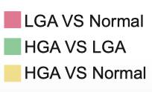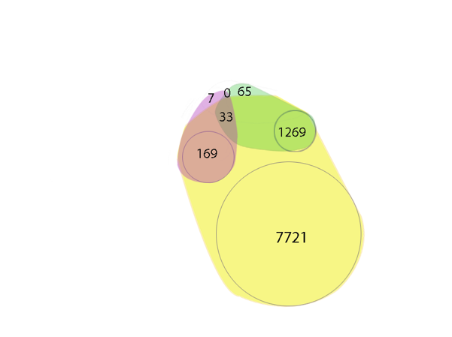 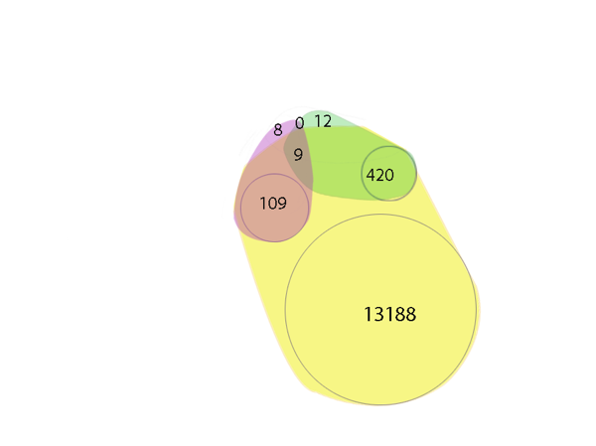

hyper hypo

**Figure S1.**  Hyper DMSs (Left) and hypo DMSs (Right) shared between HGA (High grade adenoma), LGA (Low grade adenoma) and Normal groups or specific to each group.

*“10. The section  " Landscape of DNA methylation of pre-cancerous benign lesions" is not systematic.* *The Figure 1 is just increasing this inconsistency. The authors evaluated in silico data without detailed publication of the findings in their paper ( tables, top genes,sites etc.) Here arises again the question early adenoma markers were used for adenoma detection but and why for cancer ?”*

**Response:** As mentioned above (reply 2), using adenoma tissues may lead us to discover the early marker for cancer diagnosis. A classic model of colorectal cancer development is from normal intestinal epithelial tissue to low-grade adenoma, then into high-grade adenoma, and finally into cancer. The methylation changes we observed in low-grade adenoma were enhanced or maintained in high-grade adenoma, which is consistent with the pattern of colorectal cancer progression. As a precancerous stage, we look for markers of adenoma not just to detect adenoma, but to provide a possible early window for cancer detection.

*“11. The section " Hyper-methylated CpG sites exhibited better* *discriminatory performance between normal, pre-cancerous, and cancerous tissues than the hypo-methylted pattern for CRC" relates to publicly available  278 normal, 51, adenoma, and 504 cancer samples. In this section the authors  perform in silico evaluation of  these data but  do not relate them to their own data. The reviewer asks why ?  
In any case, authors should validate the identified in silico markers in their own data, for cancer or early diagnosis for cancer or for adenomas.”*

**Response:** Since our sample size is limited, we adopted a strategy to use our data as the training set and than to take the public data as the validating set. We believe this may allow the maximum statistical effectiveness.

*“12. The identified marker set is also not detailed and unavailable for the reviewer and for any reader. This is unright and unacceptable.”*

**Response:** As mentioned in Reply 5, 7 and 9, Table S1 was included in this version.

*“13. The section 4, " the promoter of ADHFE1 my be a potential biomarker for colorectal adenoma and cancer" describes two biomarker the ADHFE1 and ACSS1. The validation of these two, LGA marker was done in silico on the publicly available data sets from GEO and Array Express.  Validation should be done by other methods, as well.  Expression analysis of mRNA or proteins from these markers should also contribute to validation.”*

**Response:** We thank reviewer’s suggestion. In our follow-up study, protein will be analyzed for further validation. Meanwhile, in fact we used TCGA data to identify the relationship between promoter methylation and transcription level of ADHFE1 and ACSS3, resulting a negative correlation as expected as shown in Figure 4.